***DESIGN OF BIDIRECTIONAL CONVERTER FOR ELECTRIC VEHICLE CHARGING STATION***

*Dr. Munish Manas Ashutosh Prakash Atul Pandey Siddharth Sharma*

*Asst. Prof, Dept. Of EE Dept. of EE Dept. of EE Dept. of EE*

*Central University of Haryana Central University of Haryana Central University of Haryana Central University of Haryana*

***ABSTRACT:*** *This paper is focused on design of bidirectional converter for electric vehicle which plays an important role in V2G system. With increase in demand of vehicles there is rise in need of non-renewable sources of energy which is the major contributor in pollution. To overcome this problem electrical vehicles are one of the most prominent technologies which has come to light. With present survey it has been noted the rise in demand for electric vehicle. Currently more than 3% of new vehicles sales which will rise to 10% by 2025. With the help of EVs we can limit the use of natural resources and it also reduce the pollution. The use of electric vehicles is possible only when there be systematically charging station as the electric vehicle is needed to be charge periodically. For this proper charging station are needed to be built at regular intermittent. There are certain problems in these charging station which can reduce the life of the batteries of electric vehicle. These problems are mainly related to power quality like harmonics, noises, voltages lags, losses etc. In this paper we come with a way to counter this issue so that the life of battery can be increased, and the quality of power also improved.*

***1. INTRODUCTION:***

*With the arrival of time, there's huge change in technology. The forthcoming technologies are more protean and robust. It has the capability to acclimatize. One of the most essential factors among them is energy (1). According to a check the gross energy consumed in the time of 2018- 2019 is of around 1181kwh per capita. According to recent check India has an aggregate of 99.4 of electricity content and among them79.8 is from reactionary energy and the remaining 17.3 is from renewable energy. Being said that there's a lot of stress in the grid while supplying and maintaining a huge force of energy diurnal base. With the passage of time there's enormous change in the automotive diligence. Traditionally energies like petrol and diesel are firstly used. But with the change in technologies, the operation of traditional energies is removed. A new conception of electric vehicles is introduced. With a present check it has been set up that by the time of 2030, Electric vehicles request is projected to reach units from a probable unit in 2019 with a composite periodic growth rate of 21.1%. The electric vehicles request has evolved fleetly with the constant support of government and guests (2,3). Electric vehicles have nearly entered the request and is huge success over the traditional vehicles* *Electric vehicles are being examined for a variety of reasons. It's regarded as one of the stylish styles which can be used in the process of barring profanations. According to the world energy council a chance of 17 of hothouse feasts released to the terrain comes from the vehicles. So, to control this intimidating rate of emigration, electric vehicles are suggested to replace the traditional vehicles. Electric vehicles are handier and are easier to use and are cheaper mode of transportation. This type of vehicles uses little or no energy for its functioning, therefore reducing the possibility of hothouse gas emigration which substantially consists of carbon dioxide.*

*Traditional energy costs have grown dramatically in recent times as a result of environmental deterioration, climate change, and a failure of fossil energies. As a result, it's critical that new and clean energy be used encyclopaedically. Electric vehicles (EVs) and plug- in electric vehicles (PEVs) are gaining fashion ability around the world (4- 6), due to the representativeness of new energy vehicles. EVs and PEVs have multitudinous advantages, including peak power regulation, peak cargo shifting, environmental protection, low cost, and so on. EVs and PEVs can be both loads and creators in grid- to- vehicle(G2V) charging and vehicle- to- grid(V2G) discharge modes (7) Both V2G and G2V operations are frequently respectable for" V2G.".*

*The power motor is unidirectional for G2V in general, which includes conventional and fast charging systems. Owing to the fact that the power of typical electrical vehicles is doubly advanced than the average ménage cargo, the grid network will be stressed by the fast charging (8). still, grid disturbances similar as uninvited peak loads, harmonics, If the G2V bowl doesn't use the most over- to- date conversion. As a result, in a V2G system, it's critical to support energy injection back to the grid. The bidirectional grid- connected AC/ DC motor, which can realize sinusoidal input current and bidirectional power inflow, is an essential part of the V2G system. The major exploration directions for bidirectional AC/ DC transformers for V2G operations are perfecting power viscosity, reducing input and affair current ripple, and having reactive power compensation capability (11- 13).*

***Present Work***

*Various AC/DC converter topologies have been utilized in the V2G system in recent years, including single-stage single-phase and three-phase, two-stage single-phase and three-phase, ZVS inverter, and so on [14, 15]. Reference [16] presents an electrical vehicle charger that uses a single-phase interleaved AC/DC boost converter. In [17], a high-performance single-phase bridgeless interleaved PFC converter is proposed. Both [16, 17] provide the same job of reducing battery charge and discharge current ripple, but none can work with a wide output voltage. Unidirectional buck-boost converters with wide output voltage are proposed in [18, 19], which can lower AC current Total Harmonic Distortion (THD). All of these converters are unable to transfer battery energy back to the grid due to the unidirectional switches. To realize the bidirectional power flow, the AC/DC matrix converters are proposed in [20]. The converter, on the other hand, is noted for its huge number of semiconductor switches and high-frequency operation, which means higher costs and heavier losses, such as switching and conduction losses. In [21], a current-source rectifier is shown with an auxiliary switching network. The study in [22] proposed a current-source rectifier with PWM pulse signal trilogy control method. [23, 24] proposes an intelligence protection technique that can be applied to high-power grid-connected converters. The maximum current control and grid voltage full-feedforward technique for three-phase voltage-source rectifiers were presented by the authors of [25, 26].*

*When utilized in V2G, the topologies discussed above have various drawbacks, including a narrow output voltage range, substantial losses, and high input current ripple. This study analyses and designs a three-phase bidirectional grid-connected converter for V2G systems, which achieves bidirectional power flow, high efficiency, unity power factor, and a wide battery pack voltage range as an effective alternative.*

***2.Literature Survey:*** *with vehicle to grid technology being an emerging subject in the field of vehicle design, it is also being the centre for all over the world because with the development of V2G technology it will help in mitigating the pollution which will eventually control the environmental degradation. With the explosion in use of battery energy storage, electric vehicles [EVs] are considered an efficient eco-friendly means of transportation. They also play their role through the interaction with electricity grid, delivering power as well as controlling the charging rate for faster charging time. EVs are able to meet this role due to grid-to-vehicle [G2V] and vehicle-to-grid [V2G] operation, providing bidirectional power flow to tackle the twin challenges of fast charging and providing ancillary services to the grid. With this technology there will be enormous motivation in customers as they can get back the cost of vehicle by supplying energies back to the grid and earning during the peak time, it will automatically help to reduce the carbon emission and creates a pollution free environment. The motivation on working in the field of vehicle to grid technologies holds the greatest factor of today’s environmental condition, increased global temperature and others. Also, with increase in population there is huge demand of electricity due to which natural resources are getting depleted day by day, with this technology we can overcome this problem as battery contains huge amount of power, so by supplying it back to the grid or wherever we want to we can eventually contribute in controlling the depletion of natural resources as well as mitigating the pollution.*

***3. Electric Vehicle:*** *Main concern of moving towards electric vehicles is pollution free environment or less carbon emission. In the case of electric vehicles, we use a battery for power storage. The energy is used to power electric vehicles for making the pollution free instead of internal combustion engines. There are various integrated models which make it more reliable and efficient. There are mainly four types of electric vehicle up until now they are as follow:*

1. *Hybrid Electric Vehicle*
2. *Plug-in Hybrid Electric Vehicle*
3. *Battery Electric Vehicle*
4. *Mild Hybrid Electric Vehicle*

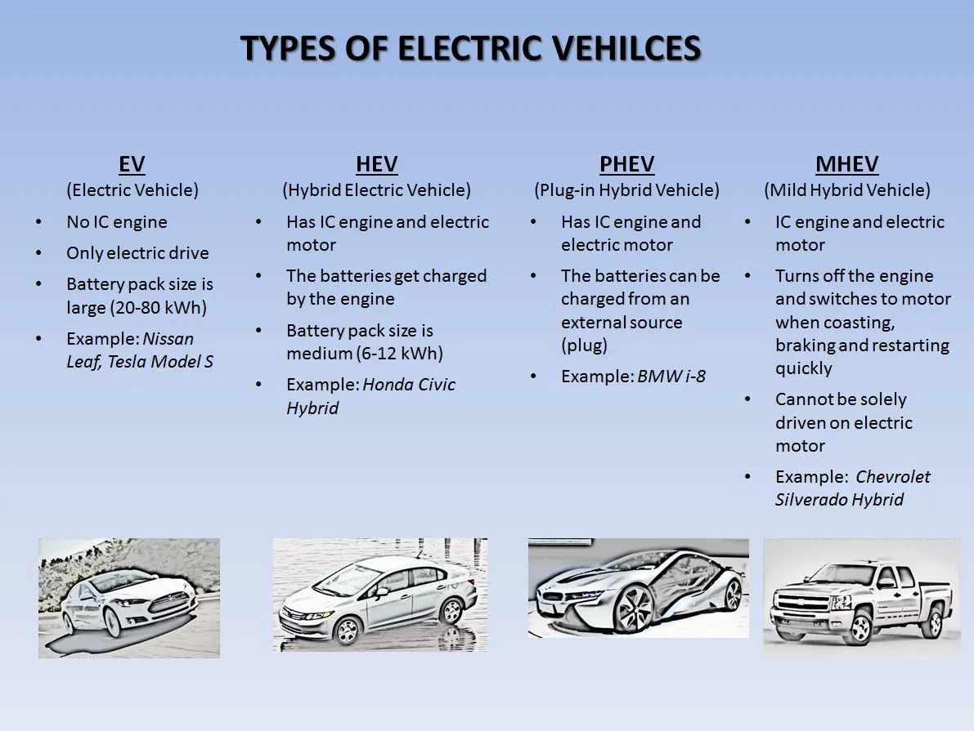

*3.1* ***Hybrid Electric Vehicle***- A hybrid electric powered car (HEV) is a kind of hybrid car that mixes a traditional inner combustion engine (ICE) device with an electric powered propulsion device (hybrid car drivetrain). The presence of the electrical powertrain is meant to gain both higher gas financial system than a traditional car or higher performance [27].

*3.2* **Plug-in Hybrid Electric Vehicle**- *A plug-in hybrid electric vehicle (PHEV) is a hybrid electric vehicle with a battery % that may be recharged each internally and externally via way of means of plugging a charging cable into an outside electric powered power source, as well as by its on-board internal combustion engine-powered generator [28].*

*3.3* ***Mild Hybrid Electric*** *Vehicle Mild hybrids (also known as power-assist hybrids, battery-assisted hybrid vehicles, or BAHVs) are cars that have an internal combustion engine and an electric machine (one motor/generator in a parallel hybrid configuration) that allows the engine to be turned off when the car is coasting, braking, or stopped, but quickly restarted [29].*

*3.4* ***Battery Electric Vehicle-****A battery electric vehicle (BEV), also known as a pure electric vehicle, purely electric car, fully electric vehicle, or all-electric vehicle, is an electric vehicle (EV) that runs only on chemical energy stored in rechargeable battery packs (e.g., hydrogen fuel cell, internal combustion engine, etc).Internal combustion engines (ICEs) are changed with electric powered automobiles and motor controllers in BEVs.[30]*

***4. Charger Topology-*** *Nowadays due to advancements in electric vehicles it will significantly affect the power grid. Vehicle-to- grid concept transfer the energy from vehicle to grid, but it generates the harmonics and power imbalance in the power system. So, to overcome power system instability, the researcher focusses on more advancement in bi-directional chargers to smoothing waveform of injecting current and active power or reactive power control during transfer of energy from vehicle-to-grid or from grid-to-vehicle. To transfer vehicle to grid it should be properly controlled and regulated. Nowadays fast charging facilities and long duration capability requires in plug-in hybrid electric vehicle which overcome by advancement in bi-directional chargers at different levels of charging. Electric vehicle charger can be broadly classified as unidirectional chargers or bi-directional chargers. If classification criteria fixed on electric vehicle design, then it classified with on-board and off-board chargers and if we take the direction of power flow then it will be categorized into conductive/ wired and inductive/ wireless chargers.*

**4.1.1UNIDIRECTIONAL CHARGER AND BI-DIRECTIONAL CHARGER**

* ***Unidirectional Charger***

Between EVs and the electric grid, two forms of power transfer are conceivable. Unidirectional chargers allow electric vehicles to charge but not to inject energy into the power grid. A diode bridge, a filter, and dc–dc converters are commonly used in these chargers. To decrease cost, weight, volume, and losses, these converters are now implemented in a single step.

* ***Bidirectional Charger***

Non-isolated or isolated circuit topologies are available for these chargers. To manage power and reactive power when operating in charge mode, they should draw a sinusoidal current with a set phase angle. The charger should return current in a sinusoidal pattern in discharge mode. A bidirectional charger can charge from the grid, inject battery energy back into the grid (known as vehicle-to-grid (V2G) operation mode), and maintain power stability.

***4.1.2CONDUCTIVE CHARGER AND INDUCTIVE CHARGER***

* ***Conductive charging system***

*Direct contact between the EV connector and the charge inlet is used in conductive charging. A conventional electrical outlet or charging station can be used to power the cable. In EV charging stations that use the conductive approach, there are two types of chargers: AC chargers and DC chargers.*

* ***Inductive charging system***

*An electromagnetic (EM) field is used to transfer energy between two objects in inductive charging. This is why a charging station was created. Inductive coupling is used to convey energy to electrical devices. Batteries are charged with this energy.*

***4.1.3ON-BOARD CHARGER AND OFF-BOARD CHARGER***

* ***On-Board charging system***

*In electric vehicles, an onboard charger consists of a dc-dc converter that converts the dc output to a safe battery charging level. An on-board charger with level 1 and level 2 charging power is included in the wireless charger. Due to weight, size, and cost constraints, on-board chargers contain a bidirectional ac-dc converter in their configuration, which transforms the grid ac supply to dc for electric vehicles, and then converts that dc into step up or step-down dc for charging the battery or supplying to the grid or home. The onboard charger may charge from single phase or three phase ac supplies, although it is only designed for single phase AC due to weight and space constraints.*

* ***Off-Board Charging System***

*In comparison to on-board charges, off-board charges are external and stand-alone. Off-board chargers have bidirectional ac-dc converters and bidirectional dc-dc converters built in. They can be used with single phase or three phase ac supply, and they can be inductive or conductive chargers. However, it is mostly used for level 3 charging or three-phase ac supply, which implies it can offer three times the amount of power in an electric vehicle. As a result, it can be used for dc fast charging.*

*4.2* ***CHARGER LEVEL***

*We’ve been refuelling our cars with gasoline for more than a hundred years. There are a few variants to choose from: regular, mid-grade or premium gasoline, or diesel. However, the refuelling process is relatively straightforward, everybody understands how it’s done, and it’s completed in about five minutes.*

*However, with electric vehicles, refuelling—the recharging process—isn’t quite as simple, or as quick. There’s some of motives because that’s so, inclusive of the reality that each electric powered car can be given specific quantities of power. There also are specific varieties of connectors used, however maximum importantly, there are specific degrees of EV charging that decide how lengthy it takes to fee an EV [31].*

*Charging levels and charging times apply to EVs and plug-in hybrids, but not to traditional hybrids. Hybrids are charged by regeneration or by the engine, not by an external charger.*

***Three types of chargers***

***4.2.1 Level 1 Charging****: A standard 120-volt household outlet is used for Level 1 charging. By putting the charging equipment into a conventional wall outlet, any electric vehicle or plug-in hybrid can be charged on Level 1. The fastest way to charge an electric vehicle is at Level 1. It increases range by 3 to 5 miles per hour.*

*Plug-in hybrid electric vehicles (PHEVs) benefit from Level 1 charging because their batteries are smaller, often less than 25 kWh. Because EV batteries are significantly larger, Level 1 charging is too sluggish for most everyday charges, unless the car isn't driven very far on a daily basis. The majority of BEV owners think that Level 2 charging is more suitable for their everyday charging requirements.*

***4.2.2 Level 2 charging: [208V-240V]*** *The most common charging level for everyday EV charging is Level 2. Level 2 charging stations can be installed at home, at work, and in public places such as shopping malls, railway stations, and other sites. Depending on the power output of the Level 2 charger and the vehicle's maximum charge rate, Level 2 charging can replace between 12 and 80 miles of range per hour.*

*The majority of BEV owners opt for Level 2 charging equipment since it charges the vehicle up to ten times faster than Level 1 charging. Even if you plug in with a practically empty battery, charging from a Level 2 source frequently results in the vehicle being fully charged overnight.*

***4.2.3 Level 3 charging: [400V-900V] {DC Fast Charging****} Level 3 charging is the fastest available and can recharge an electric vehicle at a rate of 3 to 20 miles per minute. Level 3 charging, unlike Level 1 and Level 2, uses direct current instead of alternating current (AC) (DC). Level 3 chargers have a far higher voltage than Level 1 and 2 chargers, which is why you won't find them in most homes. Level 3 charging requires a high-voltage source, which is only available in a few residential locations.*

***5. System Configuration***

*The system mainly consists of three parts, the first part is power grid, the next one is converter and the last one is load which is battery in our case. Power in the form of AC voltage supplied by the grid to the converter through transformer. Converters consist of two-part AC/DC converter in order to convert the AC voltage into DC voltage and DC/DC bidirectional converter connects the battery to the DC bus to either step up the voltage i.e., charging mode or step down the voltage which is to be considered as discharging mode. In the project charging of battery is defined as positive on the other hand discharging determined as negative. Fig 5.1 and fig 5.2 shows the circuit diagram and circuit topology of the model respectively.*

***Fig5.1[circuit diagram]***

***Fig 5.2 [model topology]***

***5.1 Bidirectional AC/DC converter –*** *The AC/DC converter which was conventionally used can only works in the rectifier mode but with development in the field of converter there is an option to flow electric power in either direction in the view of reducing the pollution by decreasing the consumption of fuel, it also supplies energy from vehicle to grid during the peak time. The central principle behind vehicle-to-grid is practicable through the integration of bidirectional AC/DC converter with a bidirectional DC/DC converter. we know about various strategies to charge the electric vehicle. It has seen that both on board and off board charging configuration with low level charges required for single phase bidirectional AC/DC charger topology. Fig 5.1.1 shows the respective BDADC.*

***Fig5.1.1:* Three phase bidirectional AC/DC converter topology**

***5.2 Bidirectional Converter:***

*A Bi-directional converter is something where power can flow at both directions.* *That approach you could feed energy to the burden and the burden also can feed the energy returned to the source. This form of converter in recent times is specifically utilized in electric powered vehicles. It is likewise referred to as a Half-Bridge DC-DC converter. When the Buck and the increase converters are linked in antiparallel throughout every different with the ensuing circuit is mostly having the equal shape because the fundamental Boost and Buck structure but with the combined feature of bidirectional power flow is called Bidirectional dc-dc converter.* *The reason of a DCDC Converter is to shift the enter DC voltage and present day to a favoured output DC voltage or present day..*

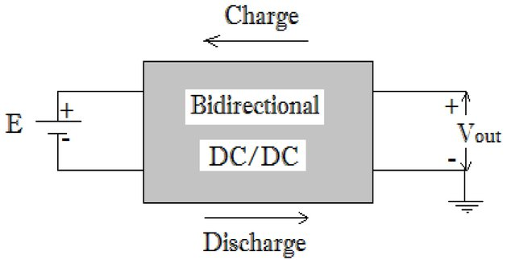

***Fig5.2.1[design of BDDDC]***

*In practice voltage shifts are done by turning discrete switches on and off very fast, chopping the input voltage. Specifically, if input side energy is greater than output side the device is working in buck mode and is a Step-Down Converter, and if input side energy is less than output side energy then it’s in boost mode and is a Step-Up Converter.*

***6. Control Strategy***

*The power structure must be controlled separately, it means that there are two different control algorithms, one for the BDC and another one for the BADC. The BDC control is responsible to decide between the two different modes of operation. If the power must be injected into the grid, the DC-DC converter assumes the V2G mode and acts as a step-up converter. If the battery must be charged, the converter assumes the G2V mode and acts as a step-down converter*

*In this research work we are controlling different parts of model, at first, we are controlling our front-end converter which consist of bidirectional AC/DC converter and second, we are controlling the bidirectional DC/DC converter with the help of PI controller. In this we are transforming our grid voltage in dq frame during charging of battery and vice versa during discharging of battery i.e., during v2g.*

***6.1 PI controller***

*Non-integrating processes, or those that eventually return to the same output given the same set of inputs and disturbances, require PI control [32]. A P-only controller is best suited to integrating processes. Integral action is used to remove offset and can be thought to be adjustable. In case of PI control method for different input supply voltage, less variation in output voltage is observed. It has great advantage of robustness in the presence of uncertainty and large disturbance. We also observe some oscillation and overshoot in response to the output of system. We are using pulse width modulation (PWM) in standard bidirectional DC/DC converter for generating the triggering pulses of the switches.*

***6.2 Transformation of abc to dq frame***

The abs to dq transform also known as Park Transform converts the time-domain components of a three-phase system in an abc reference frame to direct, quadrature, and zero components in a rotating reference frame. By implementing an invariant version of the park transform, the block can keep the active and reactive powers with the system's powers in the abc reference frame [33]. For a balanced system, the zero component is equal to zero [34].

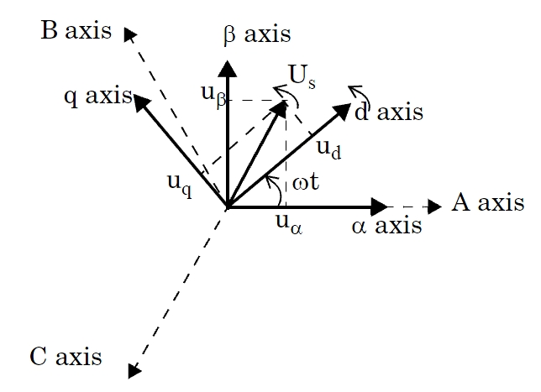

***7. Simulation and Experiment Results:***

*7.1 Simulation*

*The proposed V2G system simulation model is established in MATLAB/Simulink. Fig7.1.1 shows the respective model. In this we have taken 3-phase voltage source having phase to phase voltage of 415V and frequency 50Hz.*

*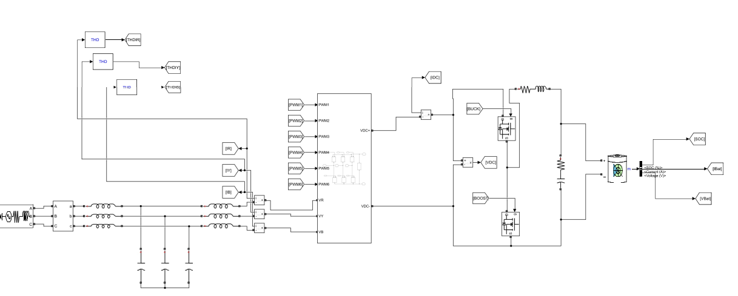****Fig7.1.1 Block Diagram of proposed model***

*We are using bidirectional AC/DC converter which is shown in fig7.1.2. for this we have use IGBT whose gate terminal is connected by PWM generators. Further this bidirectional AC/DC converter is connected to RC branch which is finally connected to the battery whose nominal voltage is 360V and rated capacity is 300V having initial state of charge =50%.*

***Fig7.1.2 Subsystem [bidirectional AC/DC converter]***

*Fig 7.1.3 shows the control scheme mentioned in section 6. The control strategy is categorised into three sub parts. The first part is inverter controller, the next one is dc bus voltage controller and rear most is battery current controller.*

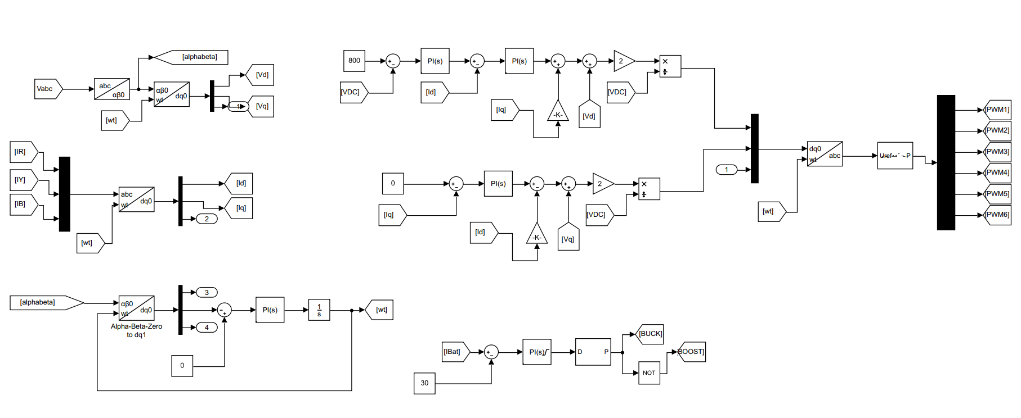

***Fig 7.1.3 [ control blocks of proposed system configuration]***

*In inverter controller the grid voltage Vabc is transformed to Vd and Vq similarly grid current Ir/Iy/Ib also transformed to the Id and Iq. The transformation is completed with the help of PLL [ phase lock loop] which set the value of wt. In DC bus voltage controller, we have taken the reference voltage of 800V by checking the results again and again with other constraints. The voltage signal is then sent to the PI control in order to reduce the steady state error without disturbing the stability of the system. Lastly, we established the battery current controller where we have taken a constant of 30V. we connect it with PI controller. we are also using DC-DC PWM generator whose switching frequency is 10000 Hz. The output of PWM generator is given to the gate terminal of the MOSFET which is working as DC-DC bidirectional converter in this model.*

***7.2 Results***

***7.2.1 Vehicle to grid mode [ battery discharging]***

*Fig 7.2.1.1 shows the simulation result when battery is getting discharge. In this case we have given constant of 30A to perform the described working. All the results and their graphs are shown ahead.*

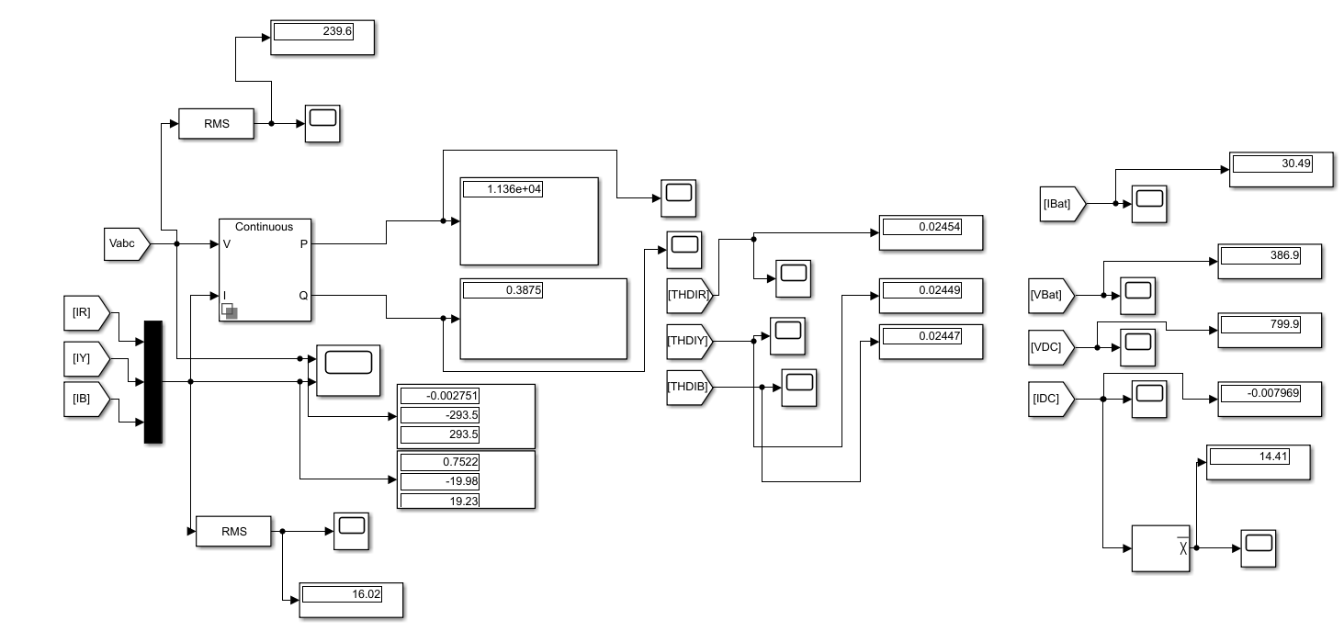

***Fig 7.2.1.1 Simulation result of battery discharging***

*.*

*Fig 7.2.1.2(i) and Fig7.2.1.2(ii) shows the simulation result of grid voltage and grid current respectively. In this graph we can observe that both the voltage and current are in the same phase which means we are injecting the power into the grid .*

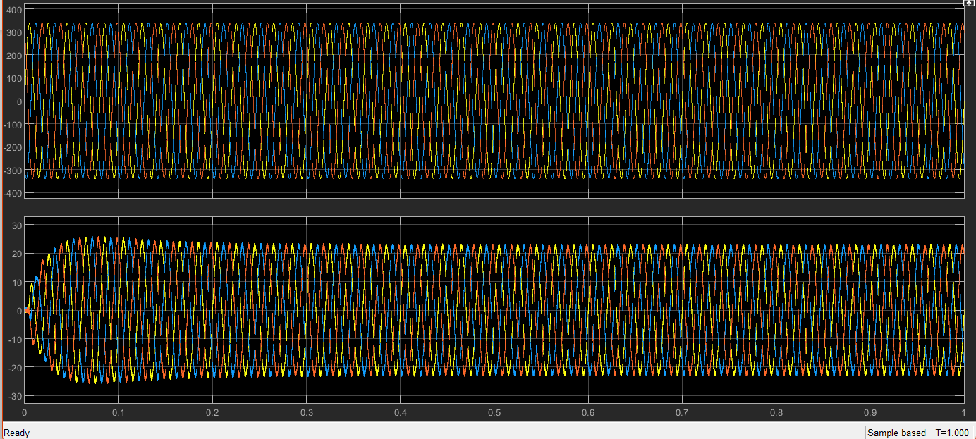 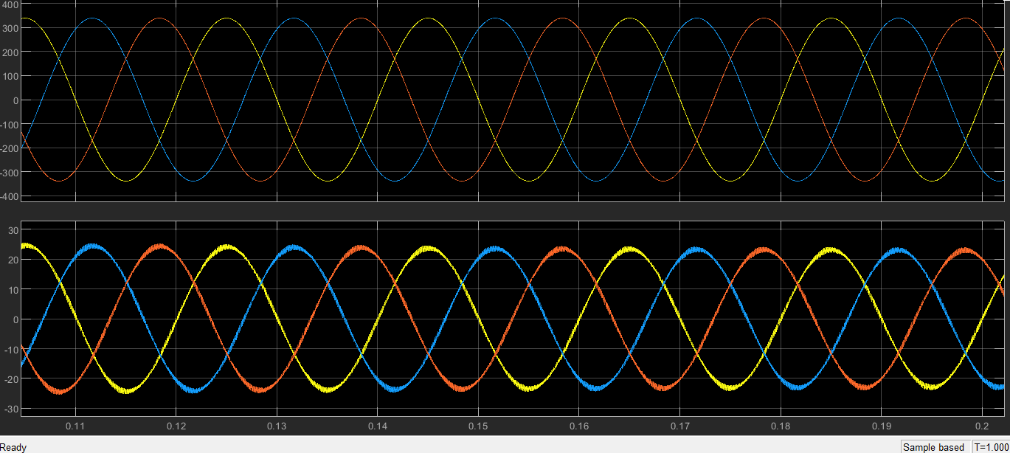

***Fig 7.2.1.2(i) Fig7.2.1.2(ii)***

*Fig7.2.1.2(iii) and Fig7.2.1.2(iv) shows the rms value of voltage and current respectively. The value of rms voltage is 239.6V, it attains the steady state in approximately 0.3 seconds. On the other hand, the value of rms current is 16.02A which also has taken 0.3 seconds to reach the steady state.*

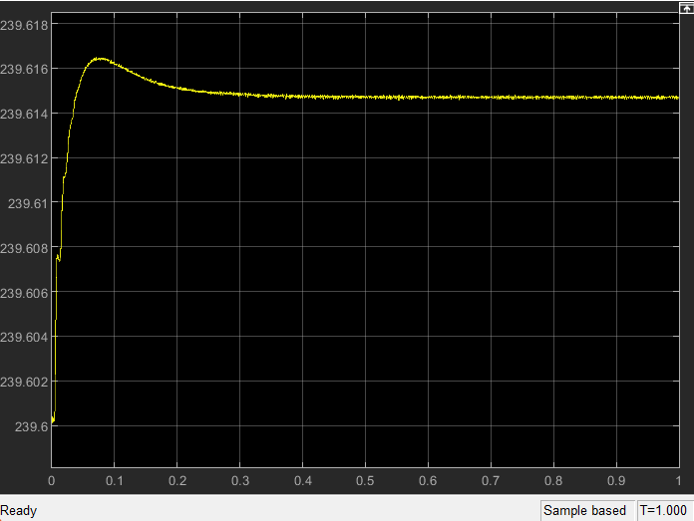 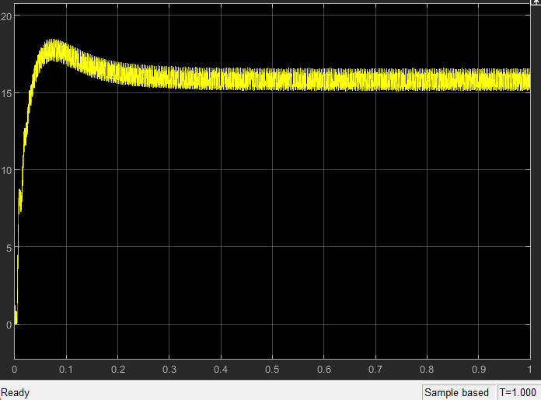

***Fig7.2.1.2(iii) [RMS Vabc]***  ***Fig7.2.1.2(iv) [ RMS Iabc ]***

*Fig 7.2.1.3 shows the simulation result of battery current. Initially battery current is about 56A. it takes its peak in about 0.002 seconds; the peak current is almost equal to 66A. after 0.4 seconds the battery current settles to 30A.*

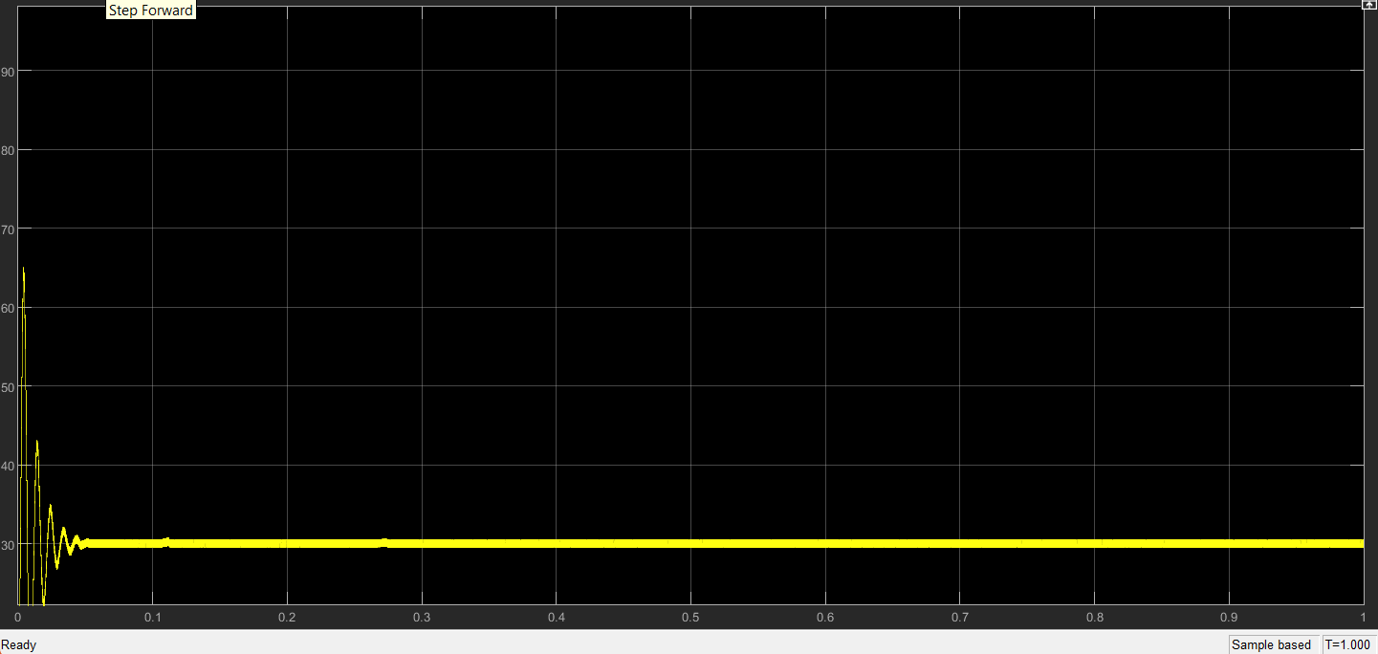

***Fig7.2.1.3 Ibat[ battery current]***

*Fig7.2.1.4 shows the simulation results of the waveform of battery voltage. Initially the voltage of battery is about 387.5V. After over 0.6 seconds it takes its steady state which is approximately equal to 387V*

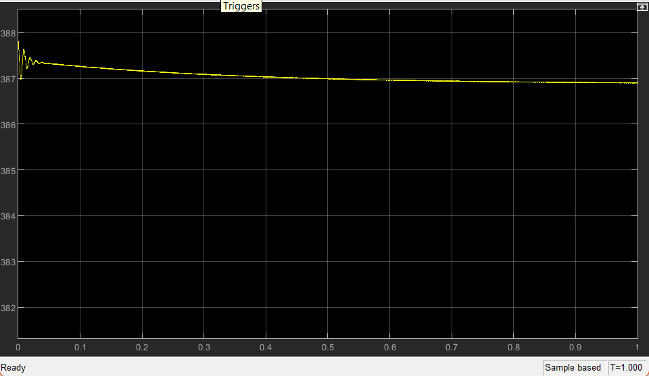

***Fig7.2.1.4 Vbat[ battery voltage ]***

*Fig7.2.1.5 shows the simulation result of bidirectional AC/DC converter’s output waveform. The output reference voltage is 800V. After about 0.4 seconds the output voltage settles to 800V that is its steady state. Maximum overshoot of Vdc is about 36V and the peak time is about 0.035 seconds. From the graph we can observe that our settling time came very soon this is due to the PI controller we have used in our model.*

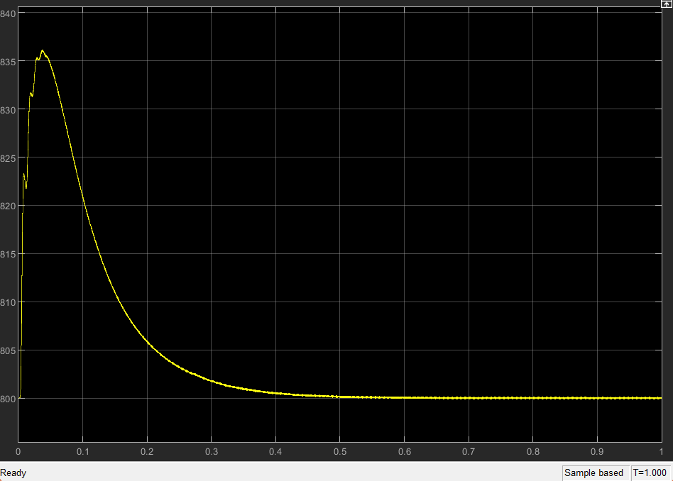

***Fig7.2.1.5Vdc [ DC voltage]***

*Fig 7.2.1.6(i) and Fig 7.2.1.6(ii) shows the simulation result of Idc. In the result it is observed that it attains its peak value of about 35A at time approximately equals to 0.016 seconds. The graph reaches its steady state at around 0.045 seconds which is equal to our reference that is 30A.*

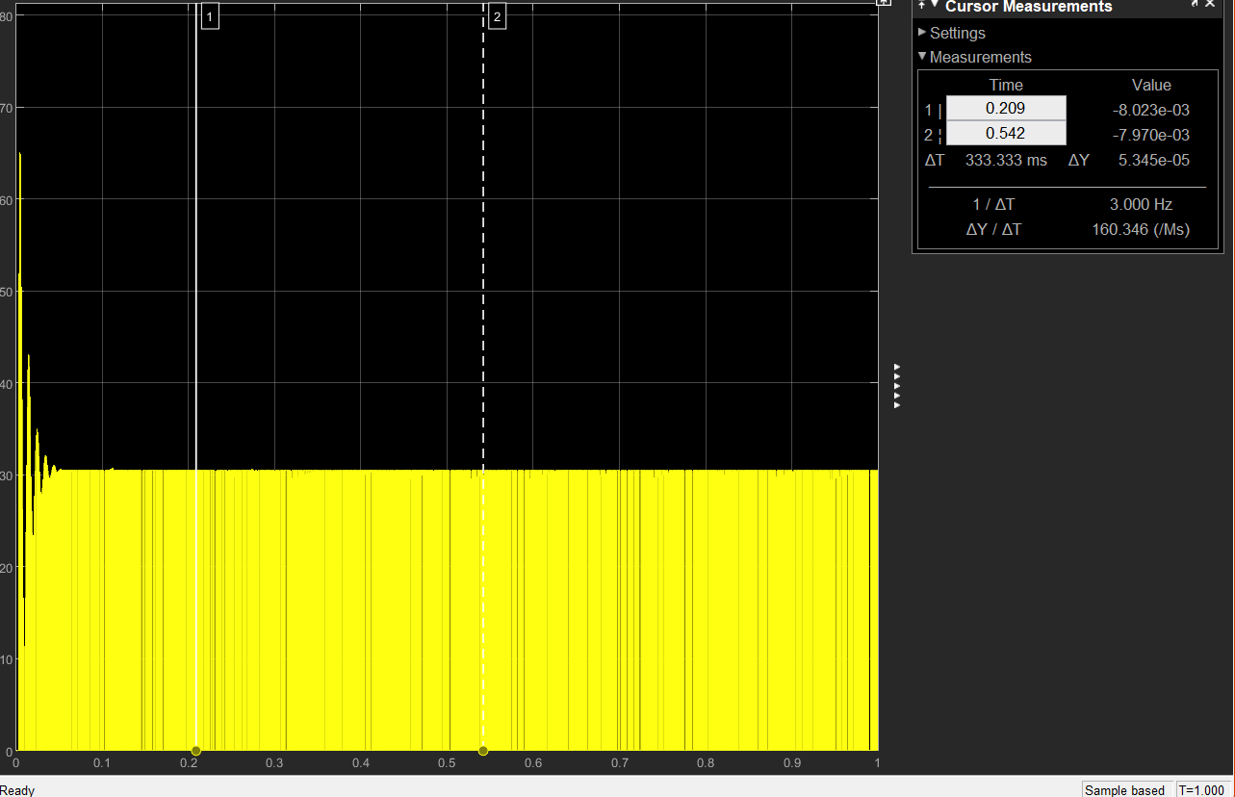

***Fig 7.2.1.6(i) [ Idc] Fig 7.2.1.6(ii) [detailed view of Idc]***

*Fig 7.2.1.6(iii) shows the average value of Idc which is equal to 14.4V. It has seen that it attains its steady state after time around 0.2 seconds. This advantage of early steady state is due to the PI controller we have used throughout in our model.*

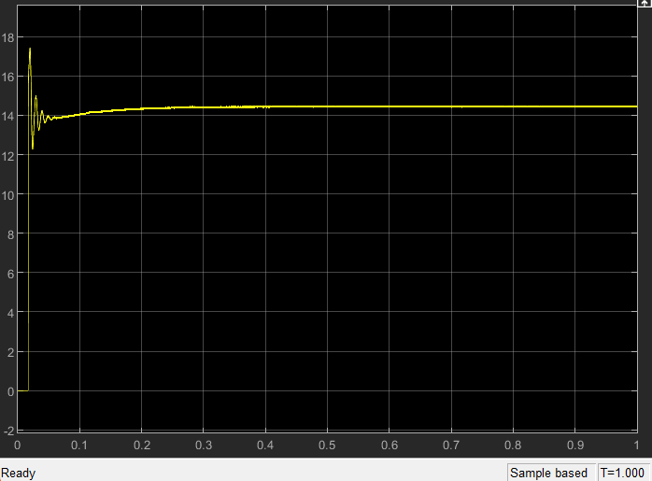

***Fig 7.2.1.6(iii) [ Average Idc]***

*Fig 7.2.1.7[(i),(ii) and (iii)] shows the simulation result of THDs of phase current Ir, Iy and Ib respectively. The value of Ir, Iy and Ib are 0.0245, 0.02449 and 0.02449 respectively which is equal to around 2.4% which lies within the range of IEEE guidelines.*

***Fig7.2.1.7(i)[THD of phase current Ir]***

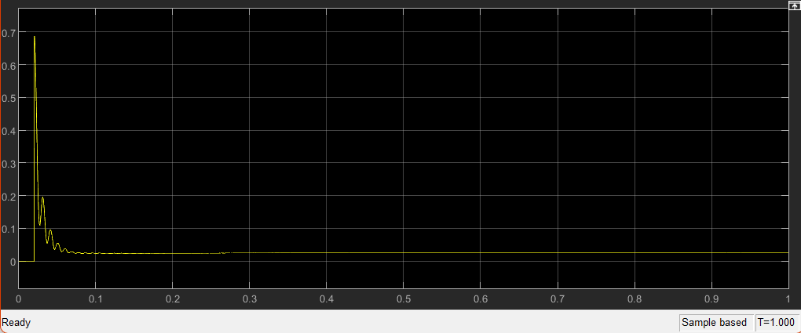 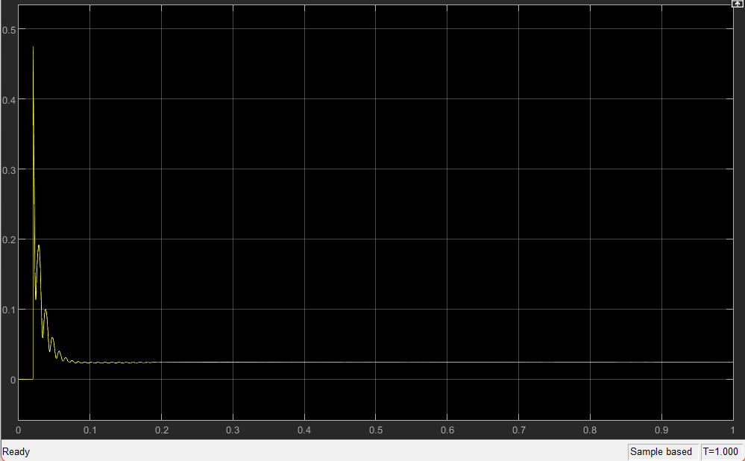

***Fig7.2.1.7(ii)[THD of phase current Iy] Fig7.2.1.7(iii)[THD of phase current Ib]***

*Fig 7.2.1.8[(i)and (ii)] shows the simulation result of Active power and Reactive power of the V2G model respectively. The active power holds the value of 1.136*10^4 whereas reactive power is 0.3875. As reactive power lies within the proposed range of IEEE, we can use it in the further V2G projects.*

***Fig 7.2.1.8(i) [Active Power P]******fig 7.2.1.8(ii) [Reactive Power Q]***

***7.2.2 Grid to Vehicle [ charging of battery]***

*In Grid to vehicle mode, we charge our battery using bidirectional AC/DC and DC/DC converter. Fig 7.2.2.1 shows the overall simulation result when battery is getting charge. We can observe the desired result by noting the values showed in display block. Section ahead shows particular results of grid to vehicle mode.*

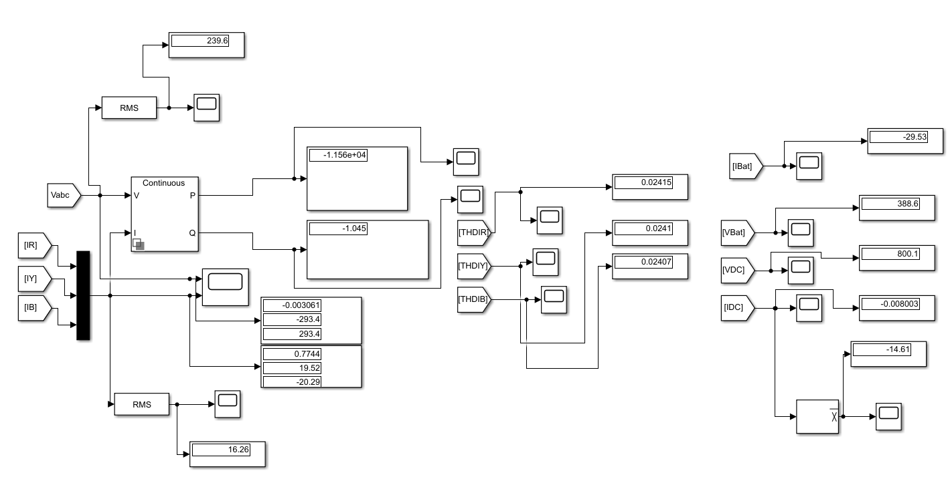

***Fig 7.2.2.1 Simulation result of battery charging***

*Fig 7.2.2.2 shows the simulation result of grid voltage and grid current respectively. In this graph we can observe that both the voltage and current are out of phase which means we are taking power from the grid to charge the battery. By observing this graph, we can define the operation of grid to vehicle mode.*

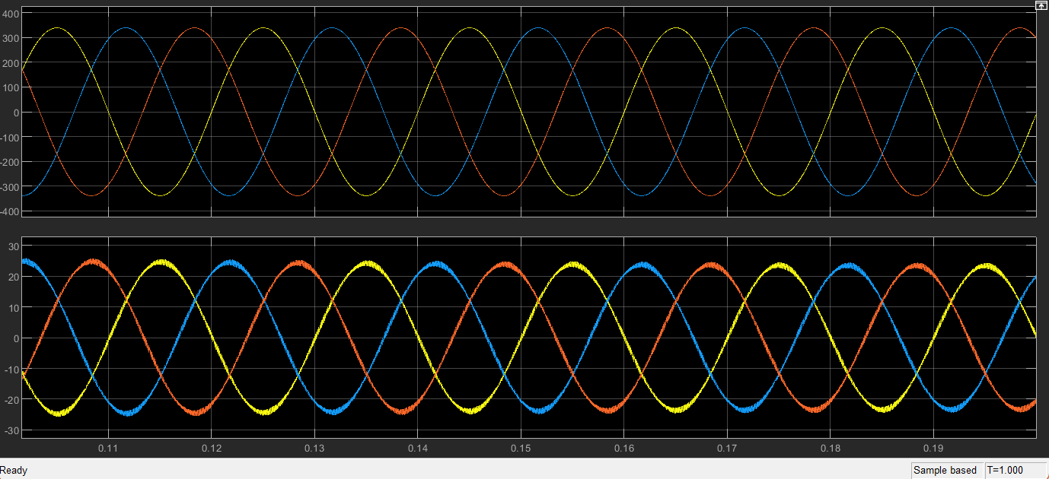

***Fig7.2.2.2[grid voltage and grid current]***

*Fig 7.2.2.3(i) and Fig 7.2.2.3(ii) are the simulation result of the rms value of voltage and current respectively. From the graph we can observe that RMS voltage is equal to around 239.586V which is attained in approximately 0.4 seconds. On the other hand, the RMS current of grid is around 15.4A, this steady state is attained in more or less in 0.3 seconds.*

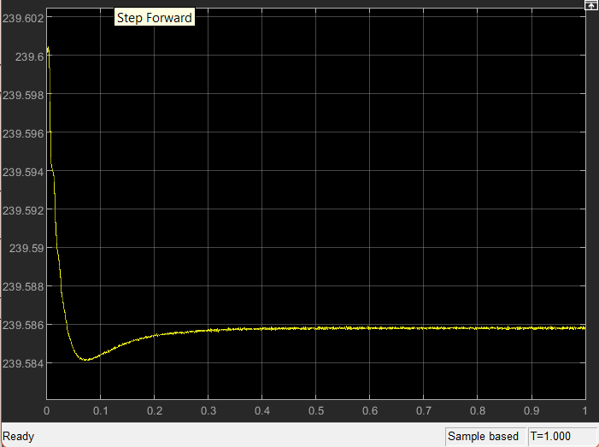  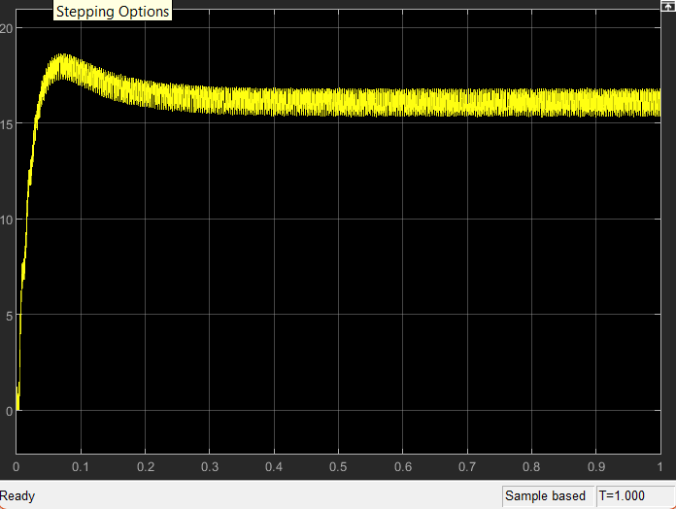

***Fig 7.2.2.3(i)[RMS Vabc] Fig7.2.2.3(ii)[RMS Iabc]***

*Fig 7.2.4 shows the simulation result of battery current. The negative value refers to the charging of battery. According to the resultant graph the current reaches to the peak of around -56A in about 0.006 seconds. It attains the steady state value of -30A in about 0.03 seconds.*

***Fig7.2.2.4[ Ibat ]***

*Fig 7.2.2.5 shows the simulation result oh the waveform of the battery voltage. From the resultant graph we can find that after 0.6 seconds the battery voltage attains the steady state of 388.6V.*

***Fig 7.2.2.5[Vbat]***

*Fig 7.2.2.6 shows the simulation result of bidirectional AC/DC converter’s output waveform. The output reference voltage is 800V. After about 0.45 seconds the output voltage settles to around 800.1V that is its steady state. Maximum overshoot of Vdc is about -36V and the peak time is about 0.035 seconds.*

***Fig 7.2.2.6[Vdc]***

*Fig 7.2.2.7(i) and Fig 7.2.2.7(ii) shows the simulation result of Idc. In the result it has shown that it obtained its peak value of about -35A at time approximately equals to 0.016 seconds. The graph accomplish to its steady state at around 0.045 seconds which is equal to our reference that is -30A.*

***Fig 7.2.2.7(i)[Idc] Fig 7.2.2.7(ii)[ Detailed view of Idc]***

*Fig 7.2.2.7(iii) shows the average value of Idc which is equal to -14.4V. It has seen that it attains its steady state after time around 0.2 seconds. The negative value refers to charging of the vehicle battery. With PI controller steady state came earlier.*

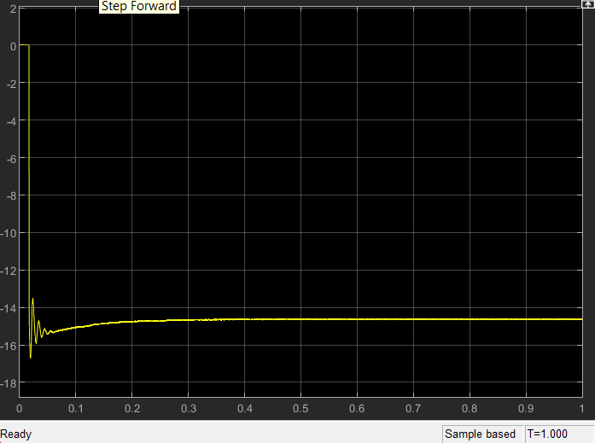

***Fig 7.2.2.7(iii)[Average of Idc]***

*Fig 7.2.2.8[(i),(ii) and (iii)] shows the simulation result of THDs of phase current Ir, Iy and Ib respectively. The value of Ir, Iy and Ib are 0.02415, 0.0241 and 0.02407 respectively which is equal to around 2.4% and according to IEEE the THD should not be greater than 5%, as the resultant THD lies within the range we can consider this results.*

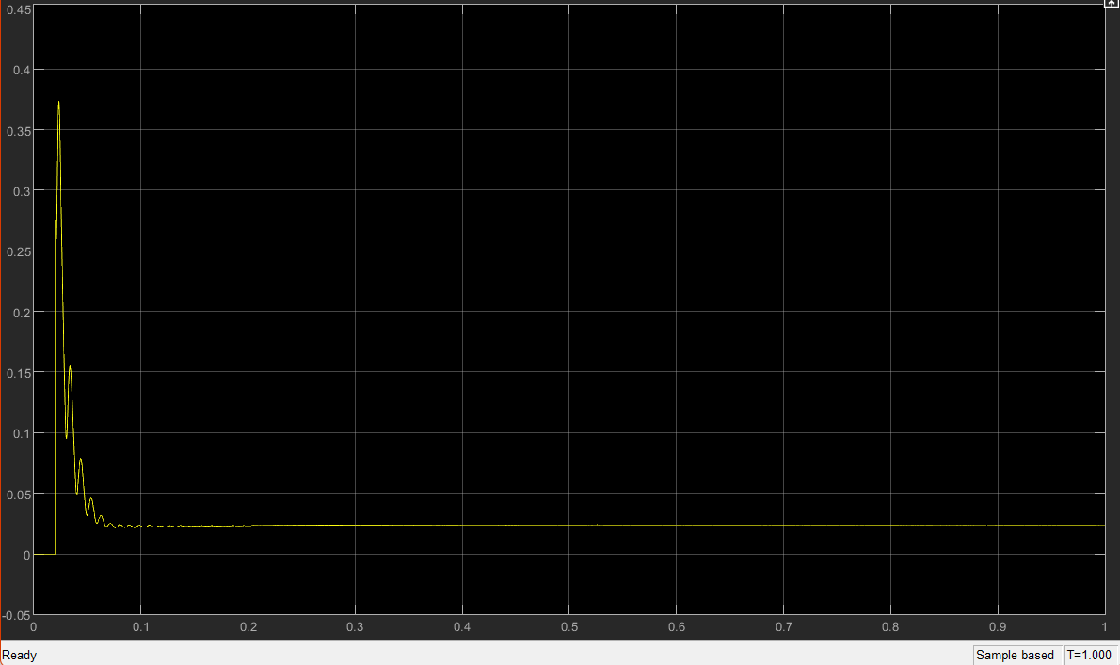

***Fig7.2.2.8(i)[THD of Ir]***

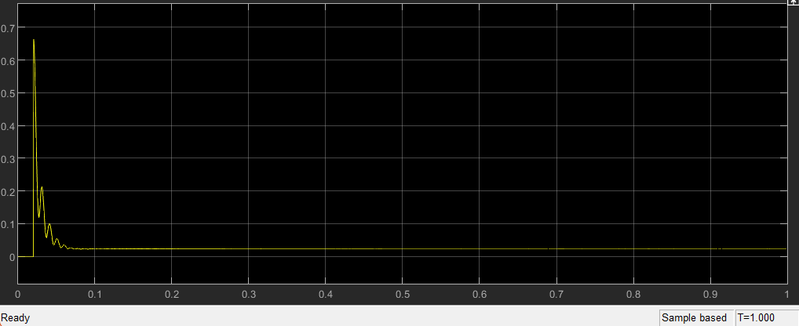

***Fig 7.2.2.8(ii)[THD of Iy] Fig 7.2.2.8(iii)[THD of Ib]***

*Fig 7.2.2.9[(i)and (ii)] shows the simulation result of Active power and Reactive power of the grid to vehicle mode. The active power controls it’s steady state value of -1.156*10^4 whereas reactive power is -1.045. As the resultant power is negative which means the power is taken from the grid to charge the battery, also the reactive power falls within the range of the guidelines set by IEEE.*

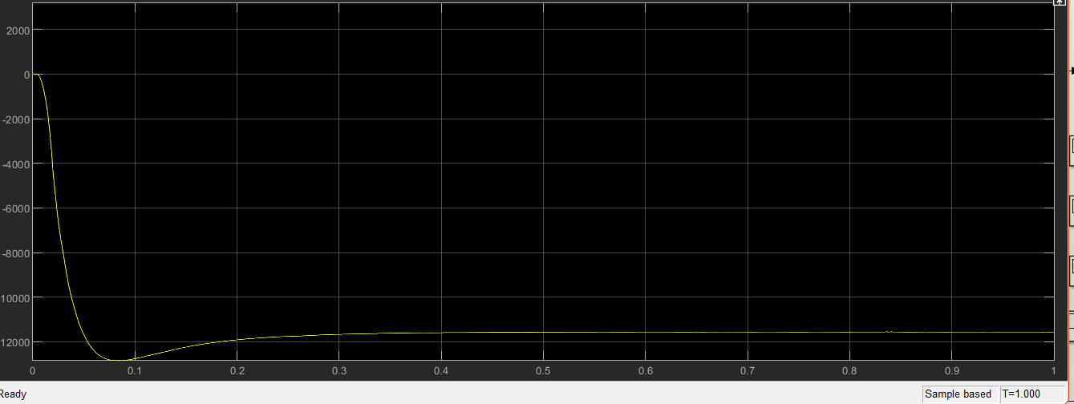

***Fig7.2.2.9(i)[Active Power] Fig 7.2.2.9(ii)[Reactive Power]***

***8. Conclusion***

*In this paper the bidirectional AC/DC and DC/DC converter was designed and simulated for electric vehicle charging station. The result for vehicle to grid and grid to vehicle was successfully achieved. In this project PI controller of voltage and current also designed in order to get quick steady state. It also produces less variation in output voltage. Also, the three phase AC/DC converter’s exact model was transformed to the synchronous d-q frame. Eventually the model is completed in MATLAB/Simulink. The result of experiment and simulation show the converter perform efficiently for both vehicle to grid and grid to vehicle application having low harmonics, low voltage ripple and low current THD. The output also verifies the active and reactive power in both the operation, with active power coming too high we are getting reactive power very low which is efficient to the work. This performance of the proposed bidirectional converter using proportional integral (PI) controller for the proposed operation that is vehicle to grid and grid to vehicle charging was then extensively investigated under the simulation study.*

***References***

*[1] A. K. Karmaker, S. Roy and M. R. Ahmed, "Analysis of the Impact of Electric Vehicle*

*Charging Station on Power Quality Issues," 2019 International Conference on Electrical,*

*Computer and Communication Engineering (ECCE), Cox's Bazar, Bangladesh, pp. 1-6.*

*2019.*

*[2] A K Karmaker, MR Ahmed, MA Hossain, and MM Sikder. “Feasibility assessment &*

*design of hybrid renewable energy based electric vehicle charging station in Bangladesh.”*

*Sustainable Cities and Society 39: 189-202. 2018.*

*[3] J. Wi, H. Kim, J. Yoo, H. Son, H. Kim and B. Kim, "Energy consumption of parallel type*

*hybrid electric vehicle with continuously variable transmission using electric oil pump,"*

*2018 Thirteenth International Conference on Ecological Vehicles and Renewable Energies*

*(EVER), Monte-Carlo, pp. 1-7. 2018.*

*[4] S. Habib, M. M. Khan, F. Abbas, L. Sang, M. U. Shahid, and H. Tang, “A comprehensive study of implemented international standards, technical challenges, impacts and prospects for electric vehicles,” IEEE Access, vol. 6, pp. 13866–13890, 2018.*

*[5] S. Esther, S. K. Singh, A. K. Goswami et al., “Recent challenges in vehicle to grid integrated renewable energy system: a review,” in Proceedings of the 2018 Second International Conference on Intelligent Computing and Control Systems (ICICCS), pp. 427–435, Madurai, India, 2018.*

*[6] P. K. Joseph, E. Devaraj, and A. Gopal, “Overview of wireless charging and vehicle-to-grid integration of electric vehicles using renewable energy for sustainable transportation,” IET Power Electronics, vol. 12, no. 4, pp. 627–638, 2019.*

*[7] M. A. Masrur, A. G. Skowronska, J. Hancock et al., “Military-based vehicle-to-grid and vehicle-to-vehicle microgrid-system Architecture and implementation,” IEEE Transactions on Transportation Electrification, vol. 4, no. 1, pp. 157–171, 2018.*

*[8] B. Sah, P. Kumar, R. Rayudu, S. K. Bose, and K. P. Inala, “Impact of sampling in the operation of vehicle to grid and its mitigation,” IEEE Transactions on Industrial Informatics, vol. 15, no. 7, pp. 3923–3933, 2019.*

*[9] T. Chen, X.-P. Zhang, J. Wang et al., “A review on electric vehicle charging infrastructure development in the UK,” Journal of Modern Power Systems and Clean Energy, vol. 8, no. 2, pp. 193–205, 2020.*

*[10] S. I. Vagropoulos, G. A. Balaskas, and A. G. Bakirtzis, “An investigation of plug-in electric vehicle charging impact on power systems scheduling and energy costs,” IEEE Transactions on Power Systems, vol. 32, no. 3, pp. 1902–1912, 2017.*

*[11] A. Sridhar and A. R. Prabu, Bidirectional AC-DC Converter for Vehicle-To-Grid (V2G) Applications, Marquette University, Milwaukee, WI, USA, 2015.*

*[14] B. Koushki, P. Jain, and A. Bakhshai, “Topology and controller of an isolated bi-directional AC-DC converter for electric vehicle,” in Proceedings of the 2016 IEEE Energy Conversion Congress and Exposition (ECCE), pp. 1–8, Milwaukee, WI, USA, 2016.*

*[15] K. V. Sing, H. O. Bansal, and D. Singh, “A comprehensive review on hybrid electric vehicles: architectures and components,” Journal of Modern Transportation, vol. 27, no. 2, pp. 77–107, 2019.*

*[16] P. Yang, T. Peng, H. Wang et al., “A single-phase current-source bidirectional converter for V2G application,” in Proceedings of the 2017 IEEE 3rd International Future Energy Electronics Conference and ECCE Asia (IFEEC 2017-ECCE Asia), pp. 704–709, Kaohsiung, Taiwan, 2017.*

*[17] A. K. Singh and M. K. Pathak, “Single-phase bidirectional ac/dc converter for plug-in electric vehicles with reduced conduction losses,” IET Power Electronics, vol. 11, no. 1, pp. 140–148, 2018.*

*[18] B. Singh and R. Kushwaha, “A PFC based EV battery charger using a bridgeless isolated SEPIC converter,” IEEE Transactions on Industry Applications, vol. 56, no. 1, pp. 477–487, 2020.*

*[19] B. Singh and R. Kushwaha, “A PFC based EV battery charger using a bridgeless isolated SEPIC converter,” IEEE Transactions on Industry Applications, vol. 56, no. 1, pp. 477–487, 2020.*

*[20] T.-L. Nguyen and H.-H. Lee, “An enhanced control strategy for AC-DC matrix converters under unbalanced grid voltage,” IEEE Transactions on Industrial Electronics, vol. 67, no. 3, pp. 1718–1727, 2020.*

*[21] D. Mishra, B. Singh, and B. K. Panigrahi, “Adaptive current control for a Bi-directional interleaved EV charger with disturbance rejection,” in Proceedings of the 2020 IEEE International Conference on Power Electronics, pp. 1–6, Smart Grid and Renewable Energy (PESGRE2020), Cochin, India, 2020.*

*[22] J. Zhao and Q. Jiang, “Research on a new control strategy for three-phase current-source PWM rectifier,” in Proceedings of the 2017 Eighth International Conference on Intelligent Control and Information Processing (ICICIP), pp. 157–161, Hangzhou, China, 2017.*

*[23] O. Noureldeen, I. Hamdan, and B. Hassanin, “Design of advanced artificial intelligence protection technique based on low voltage ride-through grid code for large-scale wind farm generators: a case study in Egypt,” SN Applied Sciences, vol. 1, no. 6, pp. 1–19, 2019.*

*[24] O. Noureldeen and I. Hamdan, “Design of robust intelligent protection technique for large-scale grid-connected wind farm,” Protection and Control of Modern Power Systems, vol. 3, no. 1, pp. 1–13, 2018.*

*[25] K. Qian, G. Gao, and Z. Sheng, “A maximum current control method for three-phase PWM rectifier for the ITER in-vessel vertical stability coil power supply,” IEEE Transactions on Plasma Science, vol. 46, no. 5, pp. 1689–1693, 2018. View at: Publisher Site | Google Scholar*

*[26] W. Li, X. Ruan, D. Pan, and X. Wang, “Full-feedforward schemes of grid voltages for a three-phase $LCL$-Type grid-connected inverter,” IEEE Transactions on Industrial Electronics, vol. 60, no. 6, pp. 2237–2250, 2013.*

*[27]* *Wikimedia Foundation. (2022, June 11). Hybrid Electric Vehicle. Wikipedia. Retrieved June 15, 2022, from https://en.m.wikipedia.org/wiki/Hybrid_electric_vehicle*

*[28 ] Wikimedia Foundation. (2022, June 7). Plug-in hybrid. Wikipedia. Retrieved June 15, 2022, from https://en.m.wikipedia.org/wiki/Plug-in_hybrid#:~:text=A%20plug%2Din%20hybrid%20electric,internal%20combustion%20engine%2Dpowered%20generator*

*[29] Wikimedia Foundation. (2022, June 4). Mild hybrid. Wikipedia. Retrieved June 15, 2022, from https://en.m.wikipedia.org/wiki/Mild_hybrid c*

*[30] Wikimedia Foundation. (2022, June 4). Battery Electric Vehicle. Wikipedia. Retrieved June 15, 2022, from https://en.m.wikipedia.org/wiki/Battery_electric_vehicle*

*[31] Moloughney, T. (2022, April 20). What are the different levels of electric vehicle charging? Forbes. Retrieved June 21, 2022, from https://www.forbes.com/wheels/advice/ev-charging-levels/*

*[32] Solved 1. compare and explain the capital budgeting of a | chegg.com. (n.d.). Retrieved June 21, 2022, from https://www.chegg.com/homework-help/questions-and-answers/1-compare-explain-capital-budgeting-multinational-company-subsdiary-versus-parent-company--q99332064*

*[33] Clarke transform. Implement abc to dq0 transform - Simulink. (n.d.). Retrieved June 21, 2022, from https://www.mathworks.com/help/physmod/sps/ref/parktransform.html*

*[34]* *Clarke transform. Implement abc to dq0 transform - Simulink. (n.d.). Retrieved June 21, 2022, from https://www.mathworks.com/help/physmod/sps/ref/parktransform.html#:~:text=For%20a%20balanced%20system%2C%20the,at%20time%2C%20t%20%3D%200.*